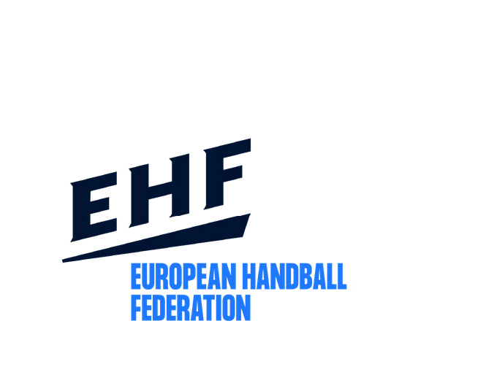
Update July 2024
EHF Club Competitions

INFORMATION on RANKING and SEEDING

Basics:

All men’s and women’s EHF club competitions are treated completely separately from each other. Both are subject to the same mathematical algorithms but are calculated strictly separately and independently from each other. Therefore, all rankings and seedings are carried out separately for men’s and women’s competitions.

TWO important terms:

RANKING SYSTEM:
The ranking system defines the number of teams for each Federation in the different EHF club competition. However, it has no influence on the seeding of a team within the competition. It defines only the number of teams that a Federation is entitled to enter in a competition (EHF club competition place distribution).

Ranking lists are normally drawn up about 12 months before the beginning of the season concerned, which means that each Federation is normally informed at the beginning of its national championship about how many places will be available in the different EHF club competitions.

The ranking lists are drawn up in June/July of each year and therefore the results of the season which just ended are considered only for the season one year later. This is due to time constraints, the most recent season cannot be taken into account in establishing the rankings for the subsequent season.

SEEDING SYSTEM:
The seeding defines the position of a team in the respective competition. Each competition has its own individual seeding valid only for this particular competition. Therefore, the same Federation may be seeded differently in each of the three men’s and women’s competitions (EHF Champions League, EHF European League and EHF European Cup.

The seeding lists are drawn up in June/July of each year and therefore the results of the season which just ended are considered.

RANKING SYSTEM:

The men’s and women’s competitions are treated completely entirely separate from each other and have no influence on each other in any way!

Calculations for the ranking system take into account a total of three seasons. The ranking for the 2025/26 season is based on the seasons 2023/24, 2022/23 and 2021/22. Due to time constraints, the most recent season cannot be taken into account in establishing the rankings for the subsequent season.

Each competition (EHF Champions League, EHF European League and EHF European Cup) will be calculated separately. That means that the points which a Federation won in one competition has no influence of the number of places in other competitions resp. on the total number of places in the EHF club competitions.

For each competition and each season, only the team of a Federation having gained the most points is used as a basis for calculations.
The key number is not the total of points won by a Federation’s clubs in the single competition, but the average which is obtained by dividing the total number of points won in this competition by the number of seasons in which the Federation was eligible to participate. This rule is necessary since, as mentioned above, not every Federation is eligible to play in each competition (e.g. EHF Champions League, EHF European Cup) in each season.
In case a Federation has starting places in a competition, but no team participate in this competition, this season will be still counted and used for the average points.

In case two or more Federations gained the same average points in one competition the Federation which earned more points in a more recent season will be ranked higher than the others. In case this differentiation is not possible, these Federations will be ranked on the same position.

How do the teams acquire their points in each competition?

- Each team is awarded with 1 point for participation in the EHF European League and EHF European Cup and with 16 points for the participation in the EHF Champions League.
- Each team is awarded with the number of points which it is entitled to based on the match result:
Win - 2 points
Draw - 1 point
Loss - 0 points

- Each team qualifying to the next round (incl. winning the finals) receives bonus points.
The number of points awarded depends on the round concerned (winning a final counts more than surviving an early round) as well as on the type of the competition (winning a round in the EHF Champions League is worth more than winning a round in the EHF European League).

Table of bonus points:
Below you find the table of bonus points which was approved by the EHF Competitions Commission and the EHF Executive Committee from the 2002/03 season. Points for men and women competitions/rounds are the same.
 | R1 | R2 | R3 | R4 | R5 | R6 | R7
EHF Champions League | 10 | 16 | 22 | 28 | 34 | 40 | 46
EHF European League | 5 | 9 | 13 | 17 | 21 | 25 | 29
EHF European Cup | 1 | 3 | 5 | 7 | 9 | 11 | 13

Due to different changes of the playing system in different competitions, the bonus points given in the different rounds were adapted as follows:
(actual points which have influence to the Ranking for the 2025/26 resp. the Seeding for 2024/25 EHF club competitions season/place distribution)

EHF Champions League Men and Women (as of 2021/22 season)
participation: 16 points
Group Phase:
place 1 and 2
(directly qualified for 1/4 finals) 76 points (see Round 1, 2, 3 and 4)
place 3 to 6: 48 points (see Round 1, 2+3)
place 7 and 8: 10 points (see Round 1)
Play-offs: 28 points (see Round 4)
Quarter-finals: 34 points (see Round 5)
FINAL4: place 1: 86 points (see Round 6+7)
place 2: 40 points (see Round 6)
place 3 and 4: 0 points
EHF European League Men (until 2022/23)
participation: 1 point
Qualification Round 1: 5 points (see Round 1)
Qualification Round 2: 9 points (see Round 2)
Group Phase: place 1 to 4: 13 points (see Round 3)
place 5 and 6: 0 points
Last 16: 17 points (see Round 4)
Quarter-finals: 21 points (see Round 5)
EHF EL Finals: place 1: 54 points (see Round 6+7)
place 2: 25 points (see Round 6)
place 3 and 4: 0 points

EHF European League Men (as of 2023/24 season)
participation: 1 point
Qualification Round: 5 points (see Round 1)
Group Matches: place 1 and 2: 9 points (see Round 2)
place 3 and 4: 0 points
Main Round: place 1: 30 points (see Round 3 and 4)
place 2 and 3: 13 points (see Round 3)
place 4: 0 points
Play-offs: 17 points (see Round 4)
Quarter-finals: 21 points (see Round 5)
EHF EL Finals: place 1: 54 points (see Round 6+7)
place 2: 25 points (see Round 6)
place 3 and 4: 0 points

EHF European League Women (as of 2020/21 season)
participation: 1 point
Qualification Round 1: 5 points (see Round 1)
Qualification Round 2: 9 points (see Round 2)
Qualification Round 3: 13 points (see Round 3)
Group Phase: place 1 and 2: 17 points (see Round 4)
place 3 and 4: 0 points
Quarter-finals: 21 points (see Round 5)
EHF EL Finals: place 1: 54 points (see Round 6+7)
place 2: 25 points (see Round 6)
place 3 and 4: 0 points

- Teams, which enter at a later stage/round of the competition, are awarded the maximum number of points they could have gained had they started in the first round, in which a match had “actually” been played (match and bonus points).
- If a competition starts at a later round because of a small number of entrants, all entrants are awarded points (match points, bonus points), as of the round that the first “actual” match in the whole competition took place.
For example: If no matches take place in the first round, all teams receive 1 participation point, as well as match and bonus points as of the second round according to the bonus point table above.
- For each competition and each season, only the best-placed team of each Federation is considered for the calculation of the ranking.

SEEDING SYSTEM:

A separate seeding list is drawn up for each competition and has its own individual seeding valid only for this particular competition. Therefore, the same Federation may be seeded differently in each of the three men’s or women’s competitions (EHF Champions League, EHF European League and EHF European Cup).

Different to the ranking, the seeding is calculated on the basis of the 3 most recent seasons. The results of the seasons 2023/24, 2022/23 and 2021/22 will therefore determine the seeding of the teams in the 2024/25 season.

The points gained per Federation, competition and season are computed analogously to the ranking procedure. Each competition is, however, regarded as being a separate entity.

Example: Ranking for the EHF Champions League

For the Champions League, only those points are relevant that were gained in the EHF Champions League in the three seasons taken into account.

In case a Federation is eligible to participate in the three seasons which are considered in the ranking then the total number of points which this federation won, will be divided by 3.

Table: Ranking of the clubs of a Federation for the 2025/26 season:

Season | Points
2023/24 | 187
2022/23 | 38
2023/24 | 73
TOTAL | 298

Over the period of the three seasons, this Federation has a total of 219 points. The calculation is therefore:
=> 298 points divided by 3 = 99,33
For the purposes of the ranking for the 2025/26 season, this Federation has 99,33 points and is ranked accordingly in the EHF Champions League.

